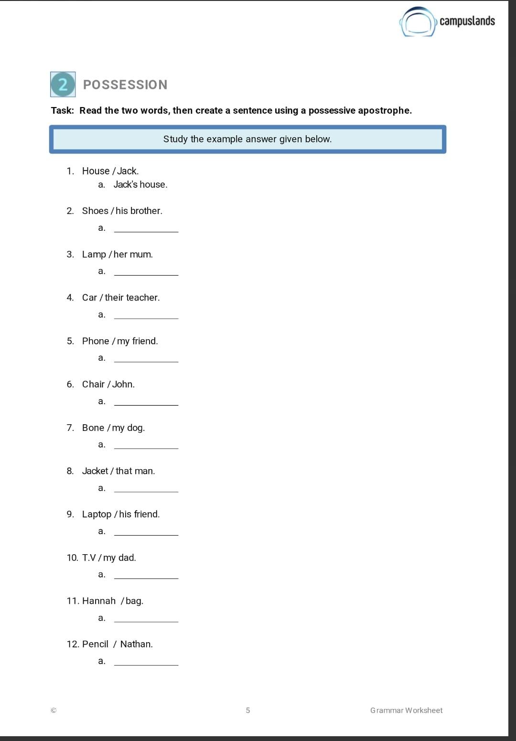
His brother’s Shoes
Her mum’s Lamp
Their teacher’s Car
My friend’s Phone
John’s Chair
That man’s Jacket
My dog’s Bone
His friend’s Laptop
My dad’s T.V
Hannah’s Bag
Nathan’s Pencil
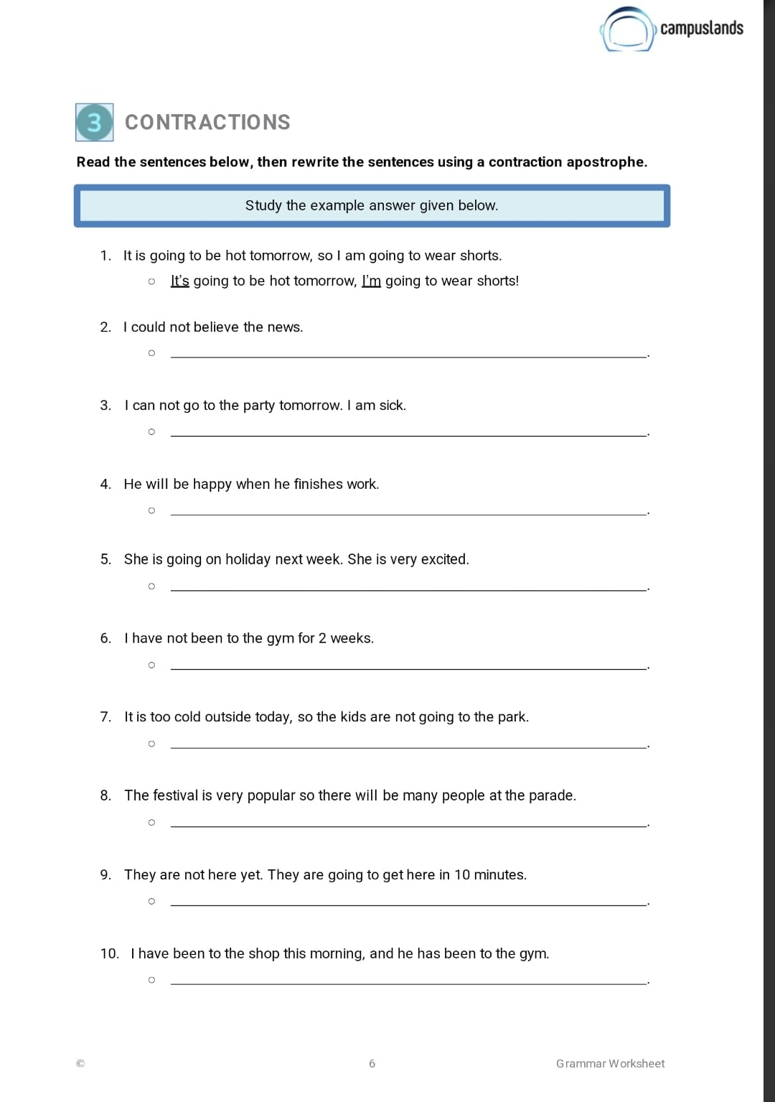
I couldn’t believe the news
I can’t go to the party tomorrow. I’m sick.
He’ll be happy when he finishes work.
She’s going on holiday next week. She’s very excited.
I haven’t been to the gym for 2 weeks.
It’s too cold outside today, so the kids aren’t going to the park.
The festival is very popular so there’ll be many people at the parade.
They aren’t here yet. They’re going to get here in 10 minutes.
I’ve been to the shop this morning, and he has been to the gym.

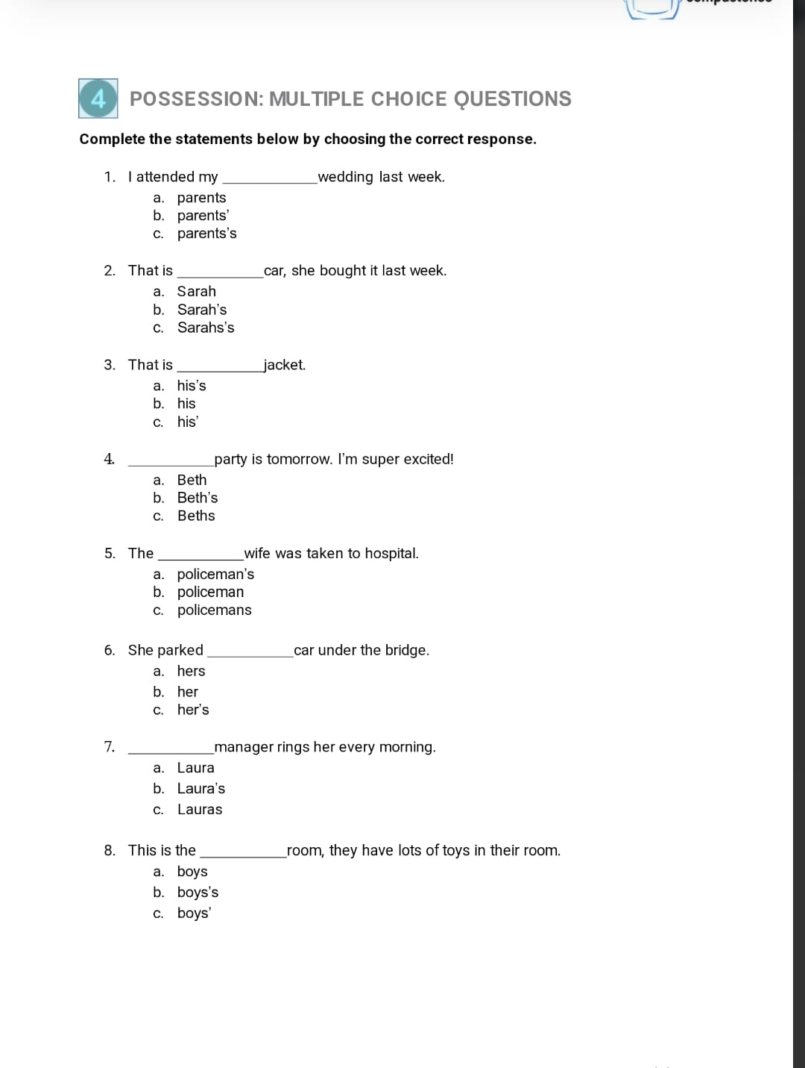
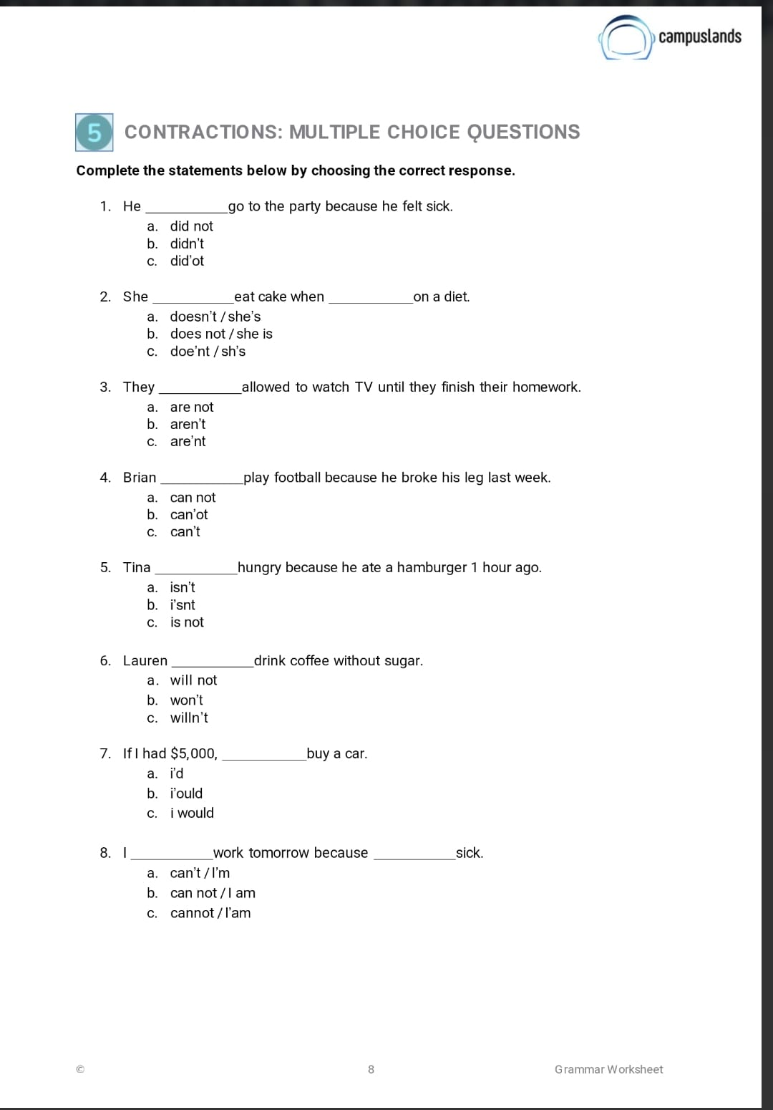

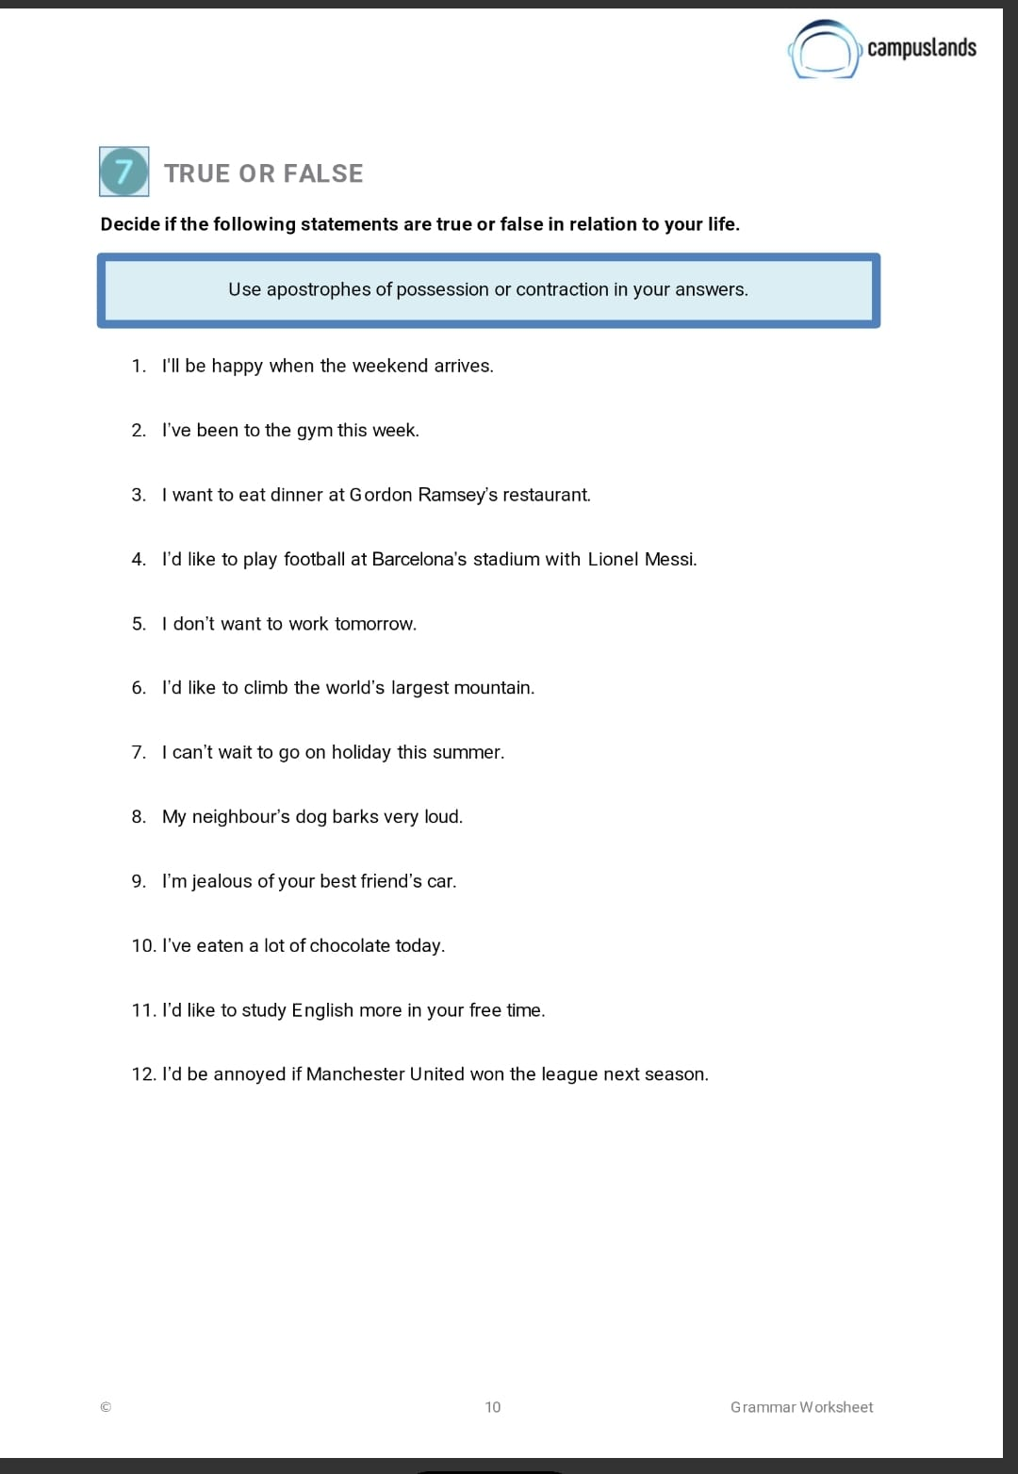
FALSE
TRUE
TRUE
FALSE
FALSE
FALSE
TRUE
FALSE
FALSE
FALSE
TRUE
FALSE
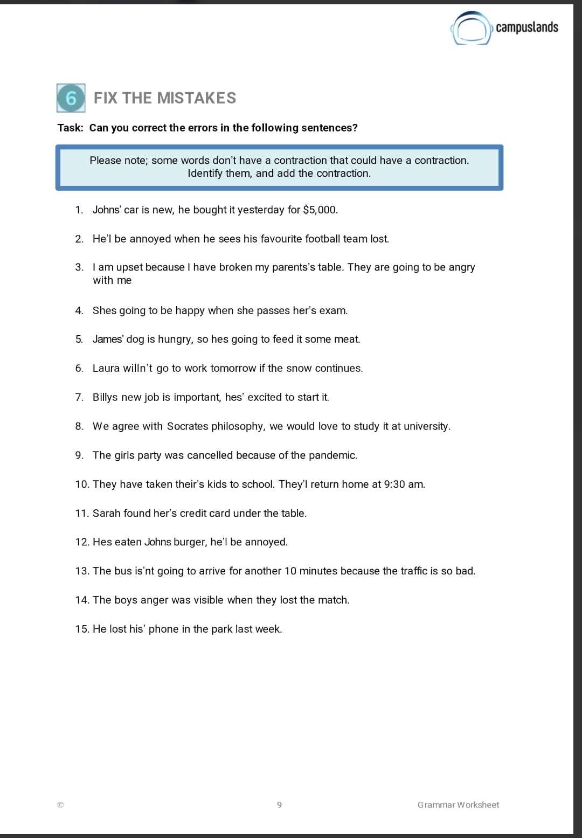
John’s
He’ll
I’m
I’ve
parents’
Theyre
She’s
Her
Jame’s
He’s
won’t
Billy’s
He’s
Socrates’
girls’
They’ll
Her
He’s
John’s
He’ll
boys’
his

